Bahria University,

Karachi Campus

LAB EXPERIMENT NO.

**04**

LIST OF TASKS

|  |  |
| --- | --- |
| TASK NO | OBJECTIVE |
|  |  |
| 1 | Where (to which window) is the output data displayed? |
| 2 | Write down the address of the first instruction of the program (see the text window) |
| 3 | Write down the value of the register $sp just before you start the program. |
| 4 | Write down the values of $a0 and $v0 after execution in Register window and why? |
| 5 | Write an assembly program that Read and Print character. |

Submitted On:

26/10/2022

(Date: DD/MM/YY)

**TASK 01:**Where (to which window) is the output data displayed?

**Output:**

**TASK 02:**Write down the address of the first instruction of the program (see the text window)

**Output:**  
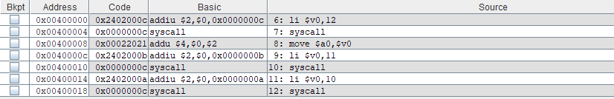

**TASK 03:**Write down the value of the register $sp just before you start the program.

**Output:**

**TASK 04:**Write down the values of $a0 and $v0 after execution in Register window and why?

**Output:**

**TASK 04:**Write an assembly program that Read and Print character.

**SOLUTION:**

.data

prompt: .asciiz "Enter Any Character :"

.asciiz "\n"

store: .byte

dis: .asciiz "\n\n You Entered : "

.text

main:

li $v0,4

la $a0,prompt

syscall

**Output:**



li $v0,12

syscall

la $s0, store

sb $v0, store

li $v0,4

la $a0,dis

syscall

lb $a0, store

li $v0, 11

syscall

li $v0, 10

syscall